***BACKEND 2 NOTES***

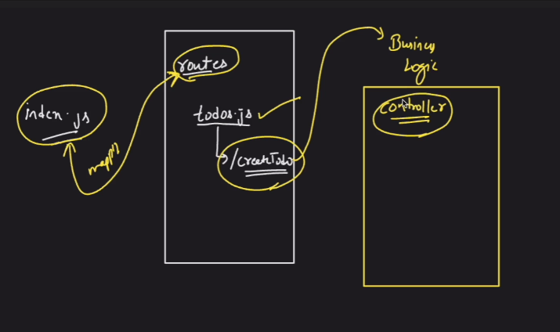

***With this I can I am able to routing from index.js to routes where let’s say I have todo.js which contains initial routes , which would be mapped to business logic inside controller to perform specific operations.***

***Controller logic tells that as soon as entry comes in createTodo add the entry inside the database***

***The description is present inside the model and what it should do is stored inside the controller.***

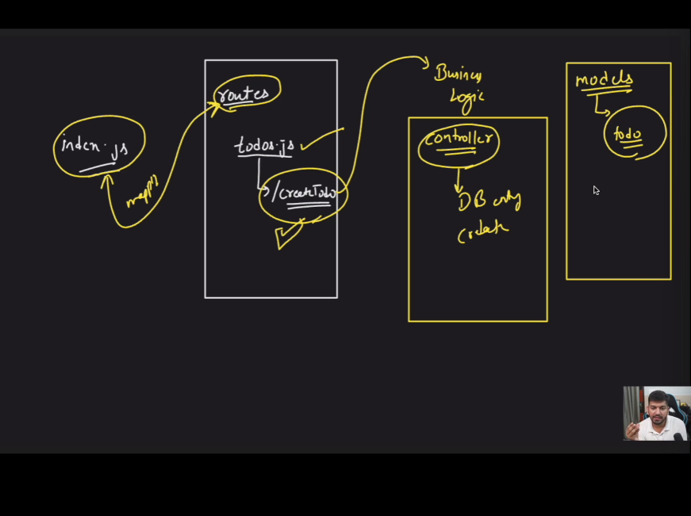

***All requests are mentioned in routes which tells about to what controllers are paths linked to. Controller has logic and model has structure. One more folder is config to make connection I will make a file database.js which connects to the database.***

***Generally .env files which defines which port number to be used.   
  
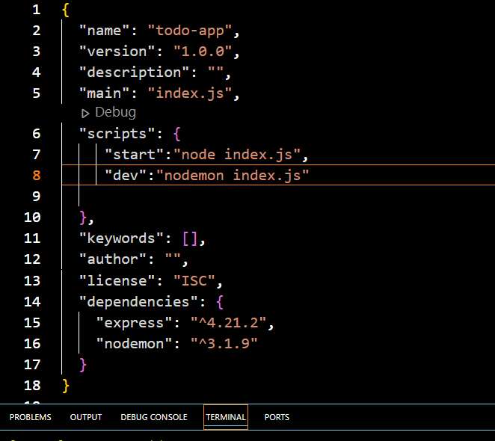  
  
adding this to the script allows us to run scripts successfully. Using dev and start  
  
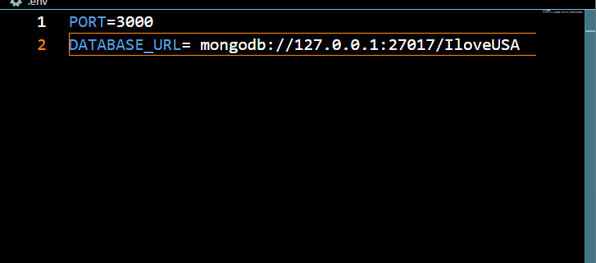add this to the .env file where we define the port and the database to connect to.***

***Not local address the 127… is the localhost is the loop back address.***

***To feed the code inside .env library I would use the .env command so that .env can be stored inside the processes.  
therefore run the .env command- npm I dotenv***

***Till 31.02***